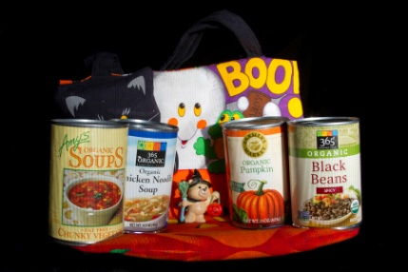 Cans Instead of Candy

This year you have an opportunity to turn Halloween into something meaningful while still having fun with your friends AND earning volunteer hours, too! On Halloween, our students are being asked to go trick-or-treating for cans instead of candy. As part of this food drive, you and your peers can get dressed up (or not… it’s up to you) and go door-to-door asking your neighbors to donate canned goods for the Capital Area Food Bank. If the neighbors offer you some candy, you are welcome to take that for yourself, but please remember that the goal is to help those who need food. As an extra bonus, the advisory that collects the most cans per person will get a baked goods treat on Monday, November 2nd.

Strategy:

Before Halloween, gather up paper bags and sturdy boxes to put your collection in. Also find up a means of wheeled transportation such as a wagon, wheelbarrow, or cart. If you don’t have one, ask a neighbor with younger kids if you can borrow theirs for the evening and explain why. Print out a few copies of the Halloween Flier to take with you. If there are multiple students in your neighborhood, please contact each other to divide and conquer the neighborhood in the best way possible.

If you have a neighborhood listserv or group, post to that list about this activity along with the details on the Halloween Flier. Let neighbors know ahead of time so they can pick up a few extra items at the grocery store.

On Halloween night, you and your friends should head out to houses which are clearly participating in Halloween by having their porch lights on. When they answer, politely ask for donations of canned goods for the Capital Area Food Bank. You may need to periodically go back to your home base and empty your wagon or cart if it is too full or heavy. Another option is to have parents follow you in a car and take canned goods back to their car every few blocks.

Please remember that you are representing our school in the wider community. If you don’t wear a costume, consider wearing a school t-shirt. Please be polite and respectful of your neighbors even if they choose not to help at this time.

Wrapping it up:

On Friday, November 1, 2013, please bring your canned goods to your adviser’s room first thing in the morning. During advisory, you will count cans and then take them to the space under the stairs in Building 4. After school, students who can drive and parent volunteers will be delivering the boxes of food to the Capital Area Food Bank on South Congress.

